MUHAMMAD KIKA FEBRIYANSYAH  Aspiring CTO & Technocrat • AI, Cybersecurity & Sustainable Technology  Tanah Baru, Depok, West Java, Indonesia  yansyah.muhammadkika01@gmail.com • +62 896-6223-5794 | 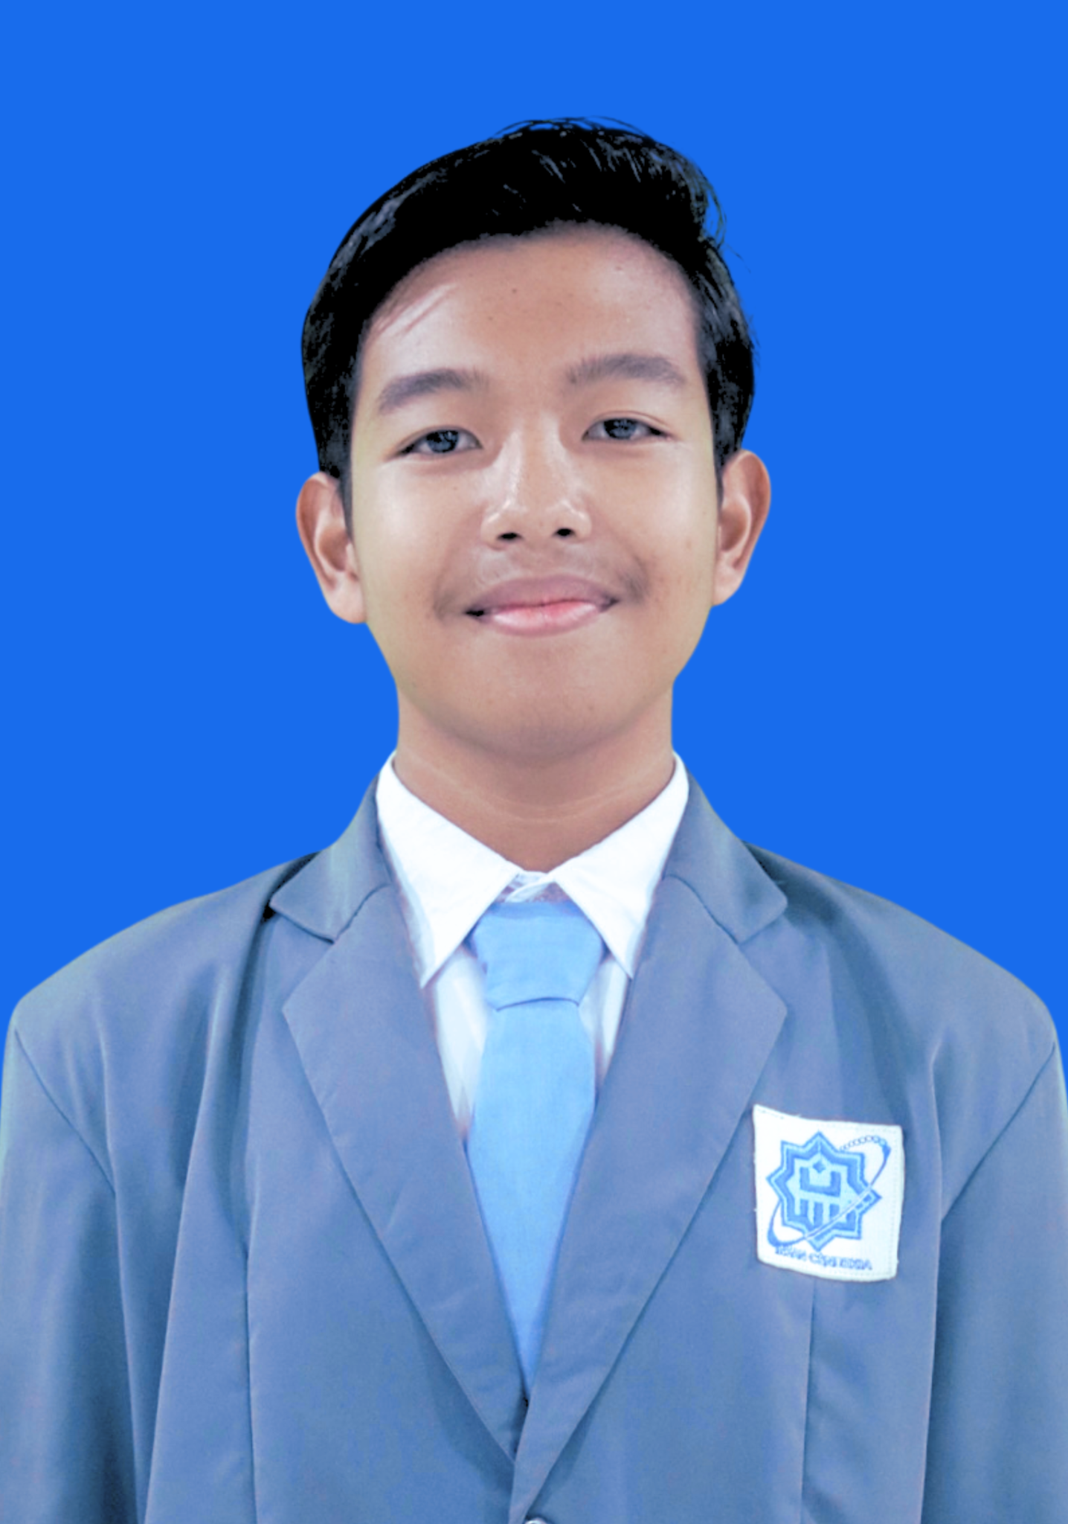

PERSONAL INFORMATION
Date of Birth | February 09, 2009 (Depok, Indonesia)
Nationality | Indonesian
Religion | Islam
Gender | Male
Address | Tanah Baru, Depok, West Java, Indonesia

PROFESSIONAL PROFILE
Highly accomplished high school student with exceptional achievements in mathematics, science, technology innovation, and leadership. Currently enrolled at MAN Insan Cendekia Serpong, Indonesia's premier national boarding school specializing in science and research excellence. Demonstrated track record of success in national and international competitions, with expertise spanning artificial intelligence, cybersecurity, environmental engineering, and mathematical olympiads.
Career Vision: Aspiring Chief Technology Officer and technocrat committed to leveraging technology for sustainable social impact, with a focus on artificial intelligence, cybersecurity, sustainable computing, and inclusive education.

EDUCATION
MAN Insan Cendekia Serpong — Senior High School
2024 – Present | Grade 11 (Class XI)
- Elite national boarding school under the Ministry of Religious Affairs
- Specialized curriculum in science, mathematics, and research methodology
- Strong emphasis on character development and academic excellence
MTsN 41 Al-Azhar Asy-Syarif Jakarta — Junior High School
2021 – 2024 (early)
- Graduated with outstanding academic performance
- Active participation in mathematics and science competitions
- Leadership roles in the Robotics Club and Islamic academic competitions
MIT Nurul Iman, Depok — Elementary School
2015 – 2021
- Foundation education with strong emphasis on Islamic values
- Early development of mathematical and scientific interests

LEADERSHIP & ORGANIZATIONAL EXPERIENCE
Founder & President TECHNOTERRA | Youth Environmental Innovation Initiative | 2025
- Established a youth-driven organization applying STEM to innovative, sustainable environmental solutions
- Led strategic direction and operations of multi-disciplinary research teams
- Organized community-based research workshops, pilot projects, and technology-transfer programs
Built partnerships with academic institutions and environmental organizations
Vice Coordinator, Majelis Permusyawaratan Siswa (MPS) | MAN Insan Cendekia Serpong | 2024/2025
- Assisted the coordinator in overseeing and evaluating the performance of student organizations
- Bridged student aspirations with school policy through the student deliberative forum
- Coordinated with various student council divisions and extracurricular units in work-program planning
Head of Research and Development Department | ADHICITA Organization | 2025
- Strategic leadership in innovation planning and research initiative oversight
- Fostered an institutional culture of intellectual excellence and sustainable development
- Coordinated cross-departmental collaboration for research project implementation
- Mentored junior researchers and facilitated knowledge-transfer programs
Head of Quiz Competition Division | Super IFUN 2025 – MAN IC Serpong | 2024
- Managed full event coordination and logistics for academic quiz competitions
- Supervised participant coordination and educational content development
Vice Coordinator | Islamic Quiz Competitions – MTsN 41 Al Azhar Asy Syarif | 2023
- Co-led the Isra Mi'raj and New Islamic Year quiz competition events
- Managed participant registration, logistics, and curriculum development
Additional Organizational Roles
- Identity Team Member — Branding of Cohort 16, MTsN 41 Al Azhar Asy Syarif (2023)
- Logo & Branding Team — Class X-5 "KI5NJARO", MAN IC Serpong (2024)
- Digital & Web Division — MAN IC Serpong Website & Communication Team (2024)

ACADEMIC ACHIEVEMENTS & HONORS
Achievements are organized by academic period to reflect the progression from junior to senior high school.
MAN Insan Cendekia Serpong (2024 – Present)
Year | Achievement | Competition | Category
2026 | Shortlisted | John Locke Institute 2026 Global Essay Prize — Science & Technology Category | Essay / Research
2026 | 1st Place | Franklin Essay Prize 2026 (General Science) | Essay / Research
2026 | Excellence Award | Lumiere Scholars Essay Award 2026 | Essay / Research
2026 | Semifinalist | Olimpiade Sains Nasional (OSN) — Ekshibisi Kompetisi Kecerdasan Artifisial (EKKA) | Artificial Intelligence
2026 | Silver Medal | Kompetisi Sains Siswa Muslim Indonesia (KoSSMI) — Artificial Intelligence, Level 4 | Artificial Intelligence
2026 | Bronze Medal | Kompetisi Sains Siswa Muslim Indonesia (KoSSMI) — Informatics, Level 4 | Informatics
2025 | Finalist | Intersect Young Researcher Competition, Stanford University | Research & Innovation
2025 | Gold Medal | Indonesia Inventors Day (IID) 2025 | Research & Innovation
2025 | Bronze Medal — Indonesian Delegation | ASEAN Science Project Competition (ASPC), Thailand | Research & Innovation
2025 | 1st Place / Gold Medal | Indonesia Science Project Olympiad (ISPO) | Research
2025 | 3rd Place | Chemurgy Innovation Summit (CIS), Institut Teknologi Bandung (ITB) | Product Innovation
2025 | 3rd Place | Essay Competition, Directorate General of Mineral and Coal, Ministry of Energy and Mineral Resources of Indonesia (ESDM) | Essay / Energy
2024 | Gold Medal | International Science and Invention Fair (ISIF) | Research & Innovation
2024 | Silver Medal | World Science and Mathematics Competition (WSMC) | Mathematics
MTsN 41 Al-Azhar Asy-Syarif Jakarta (2021 – 2024)
Year | Achievement | Competition | Category
2023 | 1st Place | ASEAN Robotic Day — Creative Middle School | Robotics
2023 | Silver Medal | International Kangaroo Mathematics Competition (IKMC) | Mathematics
2023 | 1st Place | OPTIKA Mathematics Olympiad | Mathematics
2023–2024 | Provincial Winner | Hasri Ainun Habibie Cup Olympiad | Mathematics
2023 | 1st Place + Best Participant | ODEMA VIII | Mathematics
2023 | 1st Place | Jakarta Madrasah Competition (JMC) | Mathematics
2023 | 1st Place | KSM Jakarta South City | Mathematics
2023 | Finalist | Ruangguru National Science Competition | Mathematics
2023 | Finalist | Road to National ASMOPSS | Mathematics
2023 | Top 50 | OUFEST VII | Mathematics
2023 | Honorable Mention | KoSSMI | Robotics
2022 | Silver & Bronze | Indonesia Advanced Student Competition (IASC) | Math & Science
2021 | 1st Place | Robotic Virtual Competition (RVC) | Robotics
Full certificates & awards: https://drive.google.com/drive/folders/1jO4EtT3gBSrYgBMIODkyBZV21OiRbQyG?usp=sharing

NON-ACADEMIC ACHIEVEMENTS & SPECIAL RECOGNITION
- Hifz (Qur'an Memorization) — 6 Juz
- Speaker / Presenter, INTERSECT 2025 International Conference on Research and Energy Transition, Stanford University (November 20, 2025)
- Inaugurated as SDGs Youth Action Ambassador 2026 at the Global Goals Summit 2026, Kuala Lumpur, Malaysia (January 23, 2026)
- Founder, TECHNOTERRA — a youth organization applying STEM (Science, Technology, Engineering, and Mathematics) to develop innovative and sustainable technology solutions for the environment and society
- Author of the published novel “Tak Hingga Tanpa Makna” (2026) — a work of fiction exploring the search for meaning in life, the journey through hardship and loss, and the importance of hope, resilience, and personal growth
- Selected as 1 of the Top 10 Teams, Innovation Challenge 2023 — a national youth innovation program by the Ministry of Education and Culture of Indonesia, Jakarta Education Office, and UNICEF, in collaboration with Yayasan Daya Kreasi Anak Bangsa (Markoding)
- Selected for the Complimentary Conference Pass, Kuala Lumpur International Summit on Sustainable Future (KLSF 2025)
- Selected Poet, “Perempuanku” Anthology (2023)
- Selected Poet, “Dirimu Penerus Bangsa” Anthology (2023)

ONGOING RESEARCH & TECHNOLOGY PROJECTS
A coherent research trajectory spanning AI-driven cybersecurity, Earth observation, sustainable computing, inclusive education, and the digital platform that connects them.
CYVRA — Cyber Vulnerability & Risk Analysis | AI + Cybersecurity | In development
An explainable AI-driven cybersecurity framework that correlates heterogeneous security evidence — suspicious URLs, authentication anomalies, network behavior, and known vulnerabilities — into a unified, evidence-based risk assessment. Rather than issuing isolated alerts, CYVRA fuses related evidence into a threat graph and produces a contextual risk score paired with a plain-language explanation (why the risk is high, which evidence supports it, and recommended mitigation). Planned MVP stack: Python, scikit-learn/XGBoost, FastAPI, and a graph-based correlation engine, evaluated on precision, recall, F1-score, false-positive rate, and correlation accuracy against isolated-detection baselines.
AEROFUEL — Earth-to-Flight Intelligence | AI + Earth Observation + Aerospace | NASA “Dream With Us” Challenge 2026–27 (“Fueling Future Flight”)
A geospatial-AI concept that combines satellite imagery, drone-based local observation, environmental data, and optimization to assess where future aviation energy infrastructure can coexist sustainably with ecological constraints. Satellites provide large-scale, frequent regional intelligence while drones supply high-resolution local validation; an AI layer turns both into resource and ecological-risk maps, feeding a forecasting and multi-objective optimization pipeline. An interactive environmental/aviation digital twin lets users test how energy demand, land availability, and climate conditions affect the proposed strategy, with evaluation through baseline comparison, ablation studies, and spatial validation across regions.
Technical E-Book: The Thermodynamic Bottleneck of Artificial Intelligence and the Engineering Roadmap for Sustainable Compute | AI + Sustainable Computing | In development
A technical publication examining the physical and energy constraints of scaling artificial intelligence — computation, electricity, cooling, and data-center infrastructure — and framing them as a “thermodynamic bottleneck.” It analyzes the engineering drivers of AI energy consumption (computational complexity, hardware efficiency, data movement, cooling, and facility design) and proposes an engineering roadmap covering algorithmic efficiency, hardware specialization, memory efficiency, cooling innovation, renewable-energy integration, and waste-heat utilization — directly informing a longer-term vision of building Indonesian data-center infrastructure that coexists with, rather than merely consumes, its surrounding environment.
Personal Web Portfolio | Digital Research Infrastructure | In development
A personal research-lab-style website designed to present the full body of work — Research, Project Pages, Achievements, Publications, a Lab/Experiments section, and a Timeline — as a coherent narrative rather than a list of awards. Each project page follows a consistent research structure (Problem, Research Question, Proposed Solution, Architecture, Methodology, Results, Limitations, Future Work), positioning the portfolio around four pillars: Intelligent Systems, Secure Systems, Sustainable Systems, and Inclusive Systems.
SignBridge — AI for Disability & Inclusive Education | AI + Accessibility | In development for Makau AI
An AI-powered accessibility system for Deaf and Hard-of-Hearing students that goes beyond real-time captioning to deliver genuinely accessible learning. The pipeline turns teacher speech into context-aware, academically adapted captions, recognizes and explains difficult terminology, reconstructs missed content for learning continuity, and auto-generates end-of-lesson summaries and quizzes. Planned evaluation covers Word Error Rate, academic-term recognition accuracy, contextual correction accuracy, comprehension improvement, pre-/post-test performance, and usability testing with Deaf/Hard-of-Hearing students and educators.

COMPLETED RESEARCH PROJECTS & INNOVATIONS
ARUNA — IoT-Integrated Robotic System for Marine Oil Spill Remediation Using Recycled Hair-Based Superhydrophobic Filters | Environmental Engineering | 2023 – 2025
ARUNA unifies two development phases of the same research line (previously F.L.O.W. and SPERO) into a single project. It is an autonomous, IoT-enabled robotic system that uses recycled human hair as a natural oil-absorbent medium for marine oil spill cleanup.
- Phase 1 (F.L.O.W., 2023–2024): designed the autonomous robot with sensors and IoT modules; achieved 100% oil spill area cleanup within 60 minutes in controlled simulations.
- Phase 2 (SPERO refinement, 2024–2025): engineered an ESP32-based prototype with a pump-pipe filtration mechanism; chemically modified recycled hair with stearic acid for superhydrophobic, oleophilic selectivity, reducing water absorption from 10% to 3% and achieving 92% average oil removal efficiency over 10 trials.
- Supports SDG 12 (Responsible Consumption and Production) and SDG 14 (Life Below Water) through a scalable, autonomous, waste-material-based remediation platform.
- Awards: Gold Medal, International Science and Invention Fair (ISIF) 2024; Gold Medal, Indonesia Science Project Olympiad (ISPO) 2025; Bronze Medal, ASEAN Science Project Competition (ASPC) 2025, Bangkok, Thailand.
SEGAR — Smoke Extra-ordinary Great Advance Filter Robot | Environmental Engineering | 2024 – 2025
- Engineered a multi-layered vehicle exhaust filter from upcycled waste materials: Arenga fiber (up to 70% particulate capture), Usnea sp. lichen (up to 60% CO/NOx absorption), eggshell-derived CaCO₃ (65% SO₂ neutralization), and zeolite stone (up to 80% hydrocarbon/heavy-metal capture)
- Designed as an add-on exhaust filter or fixed air purifier for high-pollution urban zones
- Supports SDG 3, SDG 11, and SDG 12
- Awards: 1st Place, ASEAN Robotic Day — Creative Middle School (2023); 3rd Place, Chemurgy Innovation Summit, ITB (2025)
KILITAKA | Waste Management Technology | 2024
- Engineered a 42-liter eco-bin with integrated biocarbon wire-mat technology for odor absorption and methane reduction
- Achieved a 40% methane emission reduction in controlled testing
- Designed for urban community waste-management optimization
SANTAI — Supreme Automatic Nanohome Technology for Amazing Innovation | IoT / Smart Home | 2024
- Designed a modular smart-home ecosystem (ESP32-based) automating lighting, temperature, ventilation, and safety features
- Enabled real-time remote monitoring via smartphone using Blynk and Firebase
- Achieved up to 30% potential energy savings in simulated home environments
- Award: Best Presentation, KoSSMI (2023)
C.L.O.N.E (Closet Online) | Sustainable Fashion Technology | 2024
- Developed an online clothing-rental platform as a circular-economy alternative to fast fashion for students
- Integrated booking, quality-control, and user-feedback systems on a subscription model with environmental-impact tracking
HEMATINA | AI / IoT + Maternal Healthcare | In progress
- Non-invasive IoT system for early detection of maternal anemia and nutritional risk using indirect biomarkers and weight monitoring
- Integrates a MAX30102 sensor (heart rate / SpO₂), a load cell with HX711 (weekly weight gain), and an ESP32 with Firebase cloud sync
- Cost-efficient prototype with OLED display and remote health-worker dashboard access, supporting SDG 3

TECHNICAL SKILLS & COMPETENCIES
Programming & Development
- Programming Languages: C++ (Advanced), Python (Intermediate)
- Web Development: front-end development, responsive design, UI optimization
- Software Design: UI/UX principles, user-experience research and implementation
- Completed the “Artificial Intelligence and Robotic Learning Program – AI Transformer Workshop,” Artificial Intelligence Center Indonesia (AICI)
Research & Academic Skills
- Mathematics: advanced olympiad-level problem solving, discrete mathematics, calculus
- Scientific Methodology: experimental design, hypothesis testing, data analysis and interpretation
- Technical Documentation: scientific writing, research-paper composition, technical reporting
- Laboratory Skills: equipment operation, safety protocols, quality-control procedures
Engineering & Technology
- Robotics: mechanical design, programming, mission planning, system integration
- Prototype Development: 3D modeling, material selection, testing and optimization
- IoT Systems: sensor integration, data collection, automated control systems
- Environmental Technology: sustainability assessment, life-cycle analysis, green-technology implementation

SOFT SKILLS & PERSONAL COMPETENCIES
Leadership & Management
- Strategic planning and project coordination across multiple organizations
- Cross-functional team leadership managing diverse skill sets and backgrounds
- Innovation management and creative problem-solving under competitive pressure
- Mentoring and knowledge-transfer with younger students and peers
Communication & Interpersonal
- Public Speaking: academic presentations, competition presentations, community workshops
- Multilingual Communication: fluent in Indonesian and English, basic Arabic
- Technical Communication: translating complex technical concepts for diverse audiences
- Cultural Sensitivity: experience across diverse religious and cultural backgrounds
Creative & Design Thinking
- Visual design and branding, with a demonstrated portfolio in organizational identity
- Creative problem-solving with a track record of innovative solutions to complex challenges
- Interdisciplinary thinking combining science, technology, and social impact

LANGUAGES
Language | Proficiency Level | Context
Indonesian | Native | Primary language
English | Advanced (Fluent) | Academic and technical communication
Arabic | Intermediate | Islamic studies curriculum

EXTRACURRICULAR ACTIVITIES & INTERESTS
Academic Interests
- Advanced mathematics research and olympiad training
- Environmental sustainability and green-technology development
- Islamic studies and interfaith dialogue
- Educational technology and digital learning platforms
Hobbies & Personal Development
- Creative writing and poetry / novel composition
- Technology entrepreneurship and startup development
- Community service and social-impact projects
- Reading contemporary science and technology literature

REFERENCES
Name | Role | Relationship
Erwin Supriatna, S.Pd. | Vice Principal for Student Affairs, MAN Insan Cendekia Serpong | Academic Reference
Reisa Suci Arimbi, M.Psi.T | Achievement Coordinator, Vice Principal for Student Affairs, MAN Insan Cendekia Serpong | Research Supervisor
Dani Amrillah | Robotics and Research Coach, ROBONICO INDONESIA | Competition Mentor

PERSONAL STATEMENT
My journey in mathematics, science, and technology has been driven by a fundamental belief that knowledge should serve humanity. From my early participation in mathematical olympiads to founding TechnoTerra, I have consistently sought to bridge the gap between academic excellence and real-world impact.
My vision extends beyond personal achievement to creating sustainable solutions for Indonesia and the broader ASEAN community. Through projects such as ARUNA and SEGAR, I aim to demonstrate that young people can contribute meaningfully to addressing climate change, energy access, and educational equity.
As I prepare for higher education and an eventual career as a Chief Technology Officer, I remain committed to the principle that technology should be inclusive, sustainable, and ethically grounded. My goal is not merely to succeed, but to create lasting positive change that will be remembered long after I am gone.
Life Philosophy: “One day you'll leave this world behind, so live a life that you will remember.”

